

**lab tasks**

**NAME:**

**Tayyaba Muslim**

**ROLL NO:**

**SU92-BSSEM-S24-076**

**SECTION:**

**BSSE-3A**

**COURSE:**

**DSA LAB**

**SUBMITTED TO:**

**Sir Rasik Ali**

**Task 01:**

**Screen shot:**

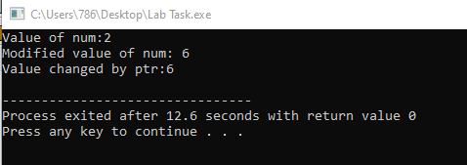

**Explanation:**

We declare an integer variable num and a pointer that holds the address of number. Modifie the value of a number by dereferencing the pointer.

**Task 02:**

**Screen shot:**

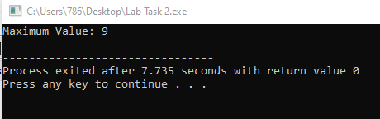

**Explanation:**

We iterate through the array once to find the maximum value.

* The time complexity is O(n) because we visit each element exactly once in the array.

**Task 03,4:**

**Screen shot:**

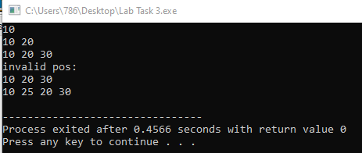

**Explanation:**

insertAtStart() inserts a new node at the beginning.

insertAtEnd() inserts a new node at the end.

The insertAtPosition() function inserts a new node at a given position.

**Task 05:**

**Screen shot:**

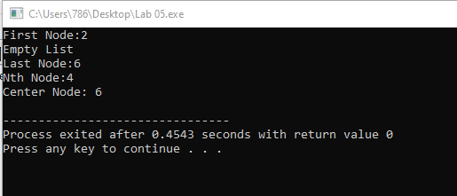

**Explanation:**

• **First Node**: Display the head node.

• **Last Node**: Traverse to the end of the list and display the last node.

• **Nth Node**: Traverse to the Nth node and display its value.

• **Center Node**: Use the slow and fast pointer technique to find the middle of the list.

**Task 06:**

**Screen shot:**

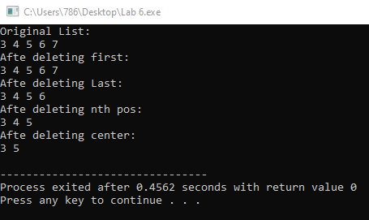

**Explanation:**

• **Delete the first node**: The head of the list is updated to the next node.

• **Delete the last node**: Traverse to the second last node, update its next pointer to nullptr, and delete the last node.

• **Delete the Nth node**: Traverse to the Nth node and delete it.

• **Delete the center node**: Use the slow and fast pointer technique to find and delete the center node.

**Task 07:**

**Screen shot:**

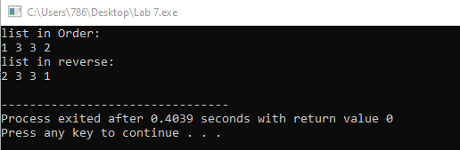

**Explanation:**

**• Insert at first**: Create a new node, set its next to the current head, and update the head.

• **Insert at last**: Traverse to the last node, then append the new node to it.

• **Insert at Nth location**: Traverse to the Nth position and insert the node at that position.

• **Insert at center**: Use the slow and fast pointer technique to find the center and insert the node there.

• **Display in order**: Traverse from head to tail.

• **Display in reverse**: Traverse from the tail to the head using the prev pointers.

**Task 08:**

**Screen shot:**

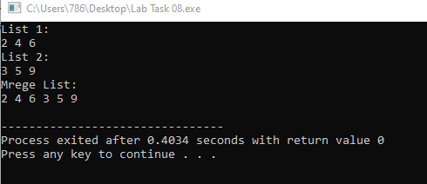

**Explanation:**

• **Singly Linked Lists**: Iterate through both lists, append the second list to the first list, and display the merged list.

• **Doubly Linked Lists**: Similarly, traverse both lists and merge them by updating the next and prev pointers.

**Task 09:**

**Screen shot:**

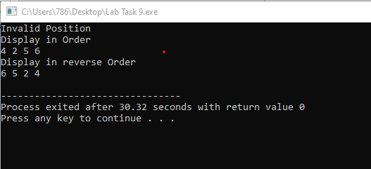

**Explanation:**

This program implements a circular linked list where the last node points back to the head. It includes functions to insert nodes at the start, end, specific position, and center, along with displaying the list in both normal and reverse order. The reverse display uses recursion, and the list supports continuous traversal without ending at null.

**Task 10:**

**Screen shot:**

**Using linked list:**

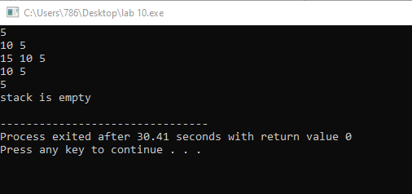

**Explanation:**

**• push()** → Creates a new node and sets it as top.

**• pop()** → Deletes the top node.

**• display()** → Prints all nodes from top to bottom.

**Using Array:**

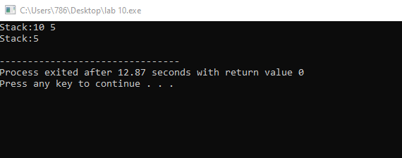

**Explanation:**

• You use an array to hold elements.

• top keeps track of the last added item.

• Each push() increases top, pop() decreases top.

**Task 11:**

**Screen shot:**

**Using linked list:**

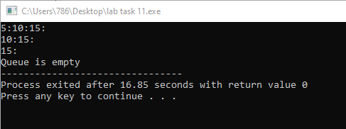

**Explanation:**

• **enqueue()** → Adds a new node at the rear.

• **dequeue()** → Removes the node from the front.

**• display()** → Shows all nodes from front to rear.

**Using array:**

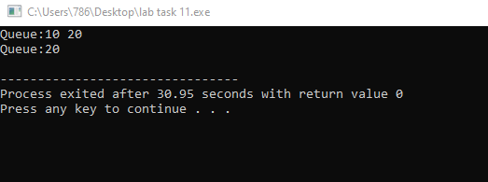

**Explanation:**

• **enqueue()** → Adds to the rear.

**• dequeue()** → Removes from the front.

• **display()** → Shows elements from front to rear.

**Task 12:**

**Screenshot of output:**

**BST:**

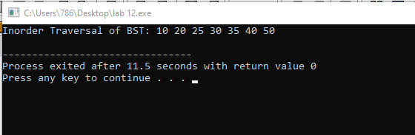

**AVL**

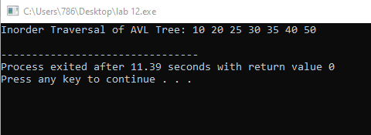

**Task 13:**

**Screenshot:**

**DFS FOR TREE:**

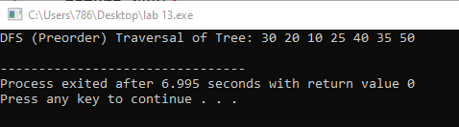

**FOR GRAPH:**

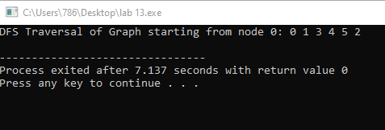

**BFS for TREE:**

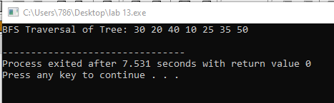

**FOR GRAPH:**

